Portland Aluminium # | SWI-PA

HIRA completed | Yes No | Ergo Assessment completed | Yes No
SIW/WIP completed | Yes No | JSA completed | Yes No

Item | Notes / Explanation
Purpose
Applied To | Windward Industries Employees
Related Documentation
Isolation
Specialised Training, Certification, Licensing
Environmental hazards and waste
Pre-operational checks & pre-work
Safety Equipment (additional to Site standard requirements)
Material Tools and Equipment

This SWI provides the operator with a Human Performance reference. The symbols and step within the chart will help the operator identify the Human Performance guidelines located in the step by step procedure.
The author needs to be mindful not to over use the Icons, thus negating the purpose and impact of an icon when observed by the reader. Insert and Icon when:

 | Safety | There is a step with potential of an Elevated Risk of injury where additional focus should be applied
 | Isolation-Lock Out/Tag Out | Here is a requirement to apply or remove a Lock & Tag
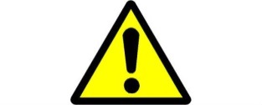 | Alert/Caution | There is a step with a potential of an elevated risk to process, production, plant where additional focus should be applied.
 | Environmental | There is a step where the lack of a control of a situation may cause an environmental incident.
 | Stop & Seek Out | A step that, if performed could cause significant harm if done incorrectly depending on the condition or equipment status.(OOPPPS)
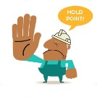 | Hold Point | There is a Process where work needs to stop until a specific step has been verified or signed off, before proceeding to the next step.

Generic hazards and safety controls
Hazard | Safety Control
- Pinch Points  - Manual Handling  - Mobile Equipment  - Noise | - Keep hand clear or identified pinch points when ……………………………….  - Handle equipment with care  - Barriers and signage used to designate work area to other mobile equipment in the area.  - Earplugs if working in noisy area or where signage is present

1 | Steps | Hazard Controls | Additional Information / Photo
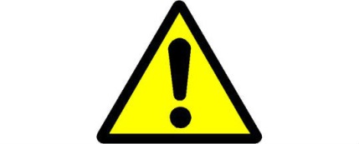

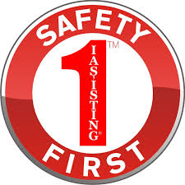


PA to carry out before taking vehicle to Windward:
 | Steps | Hazard Controls | Additional Information / Photo
2
3
4
5

